K. R. Mangalam University
School of Engineering and Technology


Operating System Lab File Course Code: ENCS351

Submitted by Submitted To
Name: Raghav Kumar Jha Dr. Satinder Roll No.: 2301010260
Program: BTech CSE Section: F

Serial No. | Assignments | Page No.
1. | Assignment 1 | 3-16
1. | 1.1 Process Creation Utility. | 3
1. | 1.2 Command Execution Using exec (). | 5
1. | 1.3 Zombie & Orphan Processes. | 11
1. | 1.4 Inspecting Process Info from /proc. | 13
1. | 1.5 Process Prioritization. | 15
2. | Assignment 2 | 17-19
2. | 2.1 Write a Python script to simulate a basic system startup sequence. | 17
2. | 2.2 Use the multiprocessing module to create at least two child processes  that perform dummy tasks. | 17
2. | 2.3 Implement proper logging to track process start and end times. | 17
2. | 2.4 Generate a log file (process_log.txt) to reflect system-like behaviour. | 17
2. | 2.5 Submit the Python script and log file along with a short report explaining  your implementation. | 17
3. | Assignment 3 | 20-34
3. | 3.1 CPU Scheduling with Gantt Chart. | 20
3. | 3.2 Sequential File Allocation. | 25
3. | 3.3 Indexed File Allocation. | 27
3. | 3.4 Contiguous Memory Allocation. | 29
3. | 3.5 MFT & MVT Memory Management. | 32
4. | Assignment 4 | 35-51
4. | 4.1 Batch Processing Simulation (Python). | 35
4. | 4.2 System Startup and Logging. | 37
4. | 4.3 System Calls and IPC (Python - fork, exec, pipe). | 40
4. | 4.4 VM Detection and Shell Interaction. | 42
4. | 4.5 CPU Scheduling Algorithms. | 46

ASSIGNMENT – 1
Process Creation and Management Using Python OS Module
TASK 1 — Process Creation Utility
Aim:
Create N child processes using os.fork().
Each child prints:
- PID
- Parent PID
- Custom Message
Parent waits for all children.
CODE :-
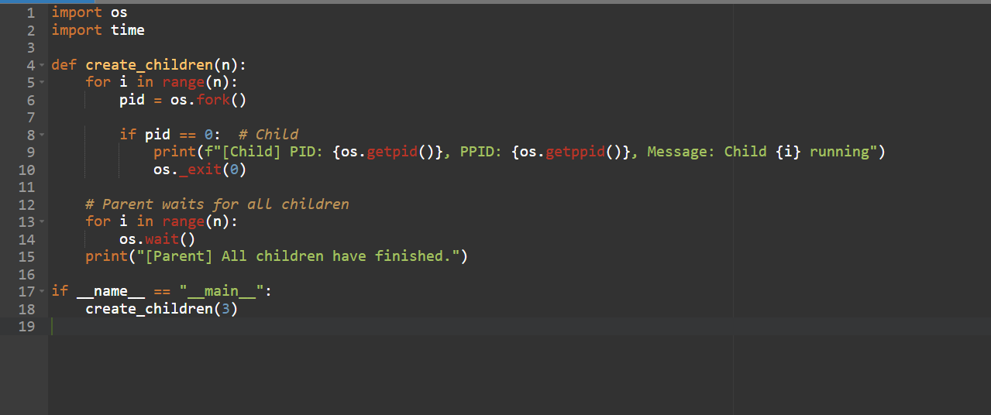

Output :-
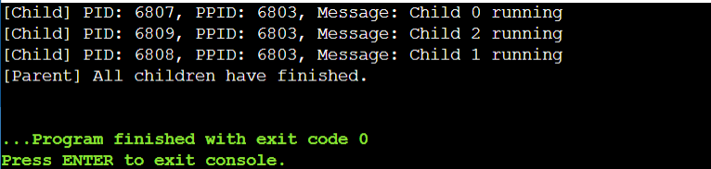

TASK 2 — Command Execution Using exec()
Aim:
Modify Task 1 so each child executes Linux commands like ls, date, ps.
Code :-
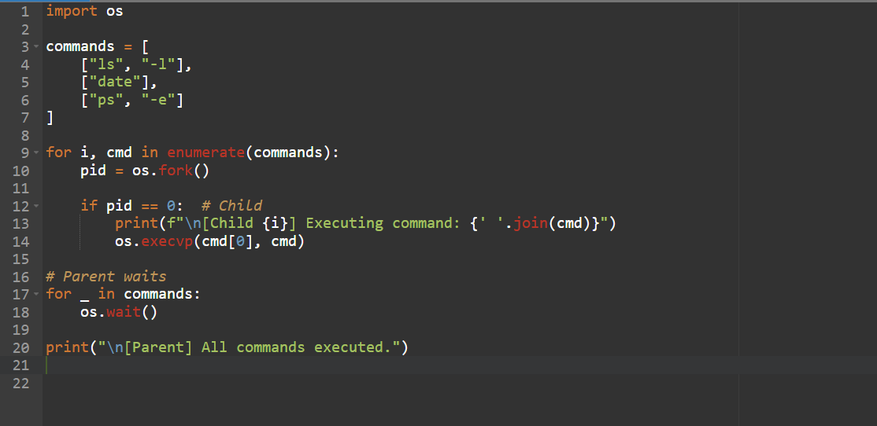

Output :-
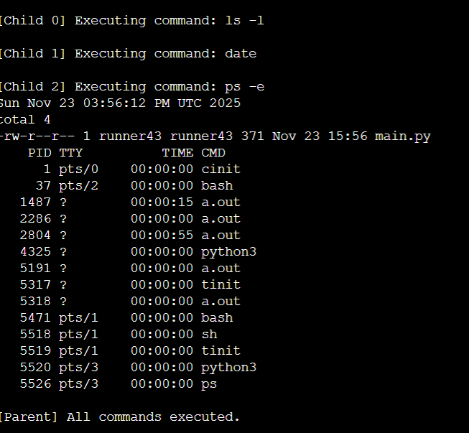

TASK 3 — Zombie & Orphan Processes
Zombie Process
A zombie occurs when:
- Child exits
- Parent does not call wait()
Code :-
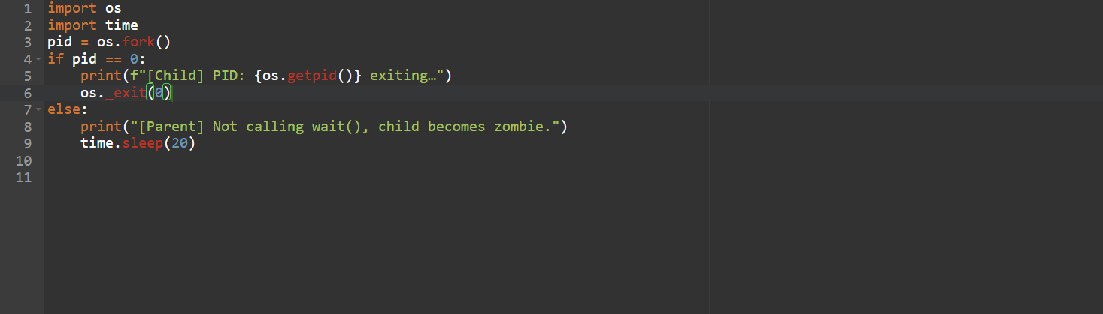

Output :-
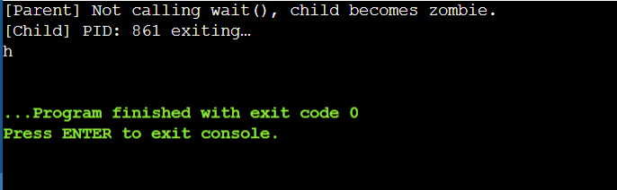

TASK 5 — Process Prioritization (nice values)
Aim:
Create CPU-intensive processes with different nice() values.
Observe scheduling difference.
Code :-
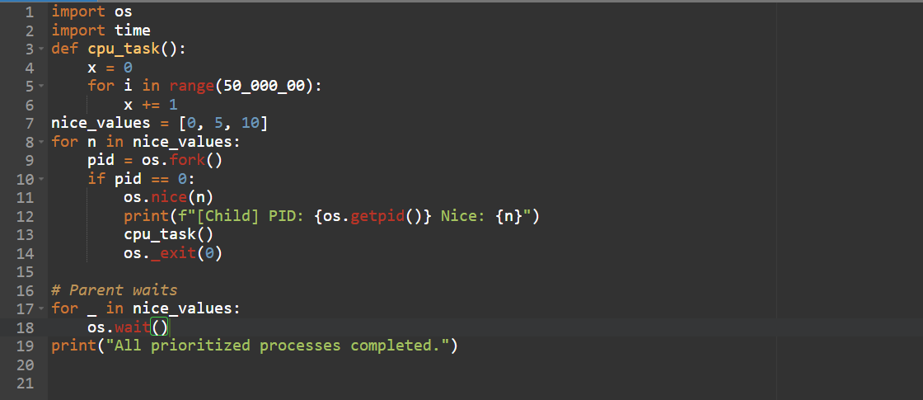
Output :-
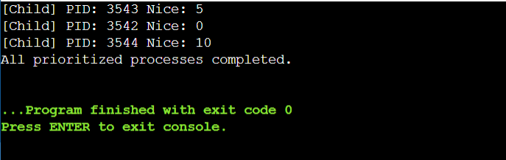

ASSIGNMENT-2
System Startup, Process Creation, and Termination Simulation in Python
Sub-Tasks:
- Sub-Task 1: Initialize the logging configuration to capture timestamped messages.
- Sub-Task 2: Define a function that simulates a process task (e.g., sleep for 2 seconds).
- Sub-Task 3: Create at least two processes and start them concurrently.
- Sub-Task 4: Ensure proper termination and joining of processes, and verify the output in the log file.

Sub-Task 1: Initialize the logging configuration
Objective: Set up the logging system to log messages with timestamps and process names.
Code :-
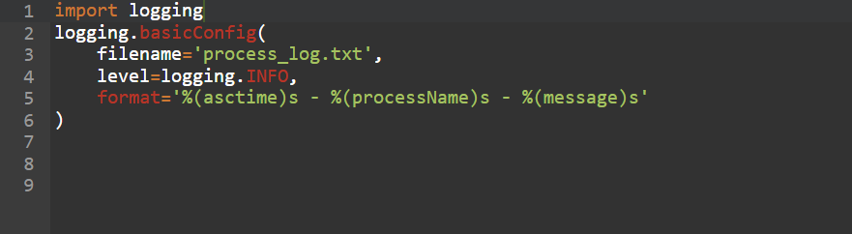
Output :-
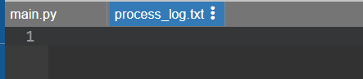
Sub-Task 2: Define a function that simulates a process task
Objective: Write a function that mimics the work of a system process.
Code: -
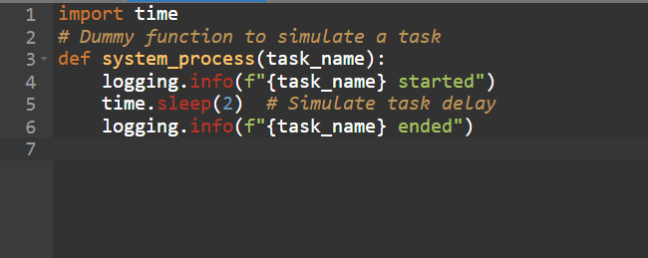

Sub-Task 3: Create at least two processes and start them concurrently
Objective: Use the multiprocessing module to initiate parallel tasks.
Code: -
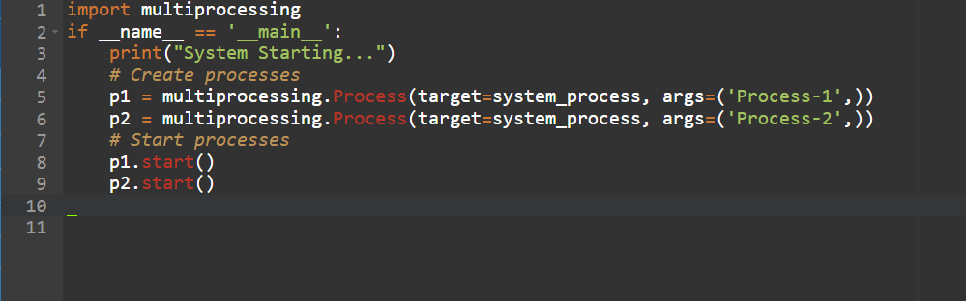

Sub-Task 4: Ensure proper termination and verify logs
Objective: Wait for processes to complete and confirm the shutdown.
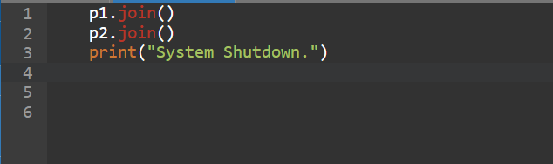
Output: -
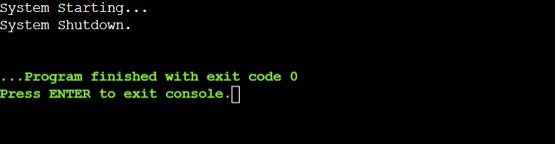

Assignment -3
Simulation of File Allocation, Memory Management, and Scheduling in Python
Assignment Tasks:
Task 1: CPU Scheduling with Gantt Chart
Code: -
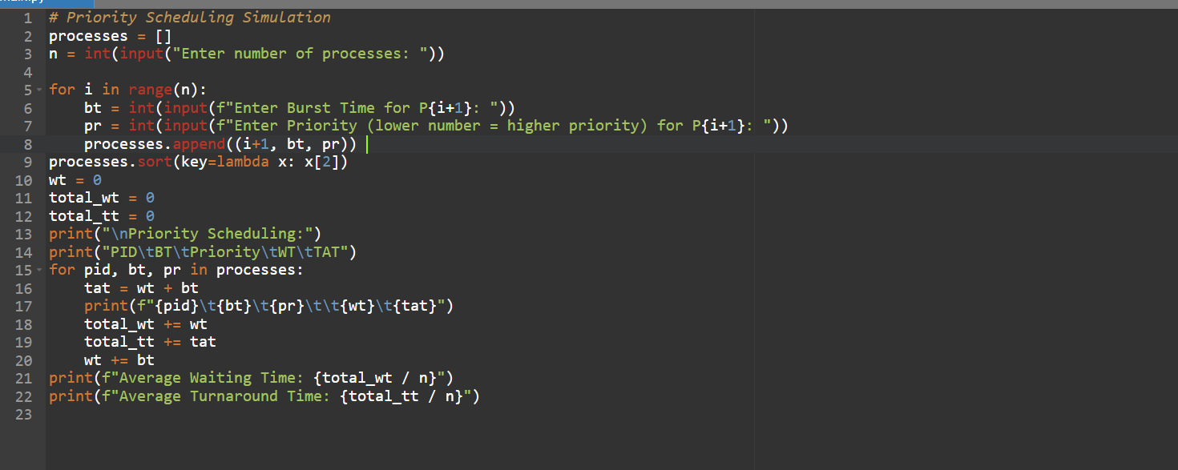
Output: -
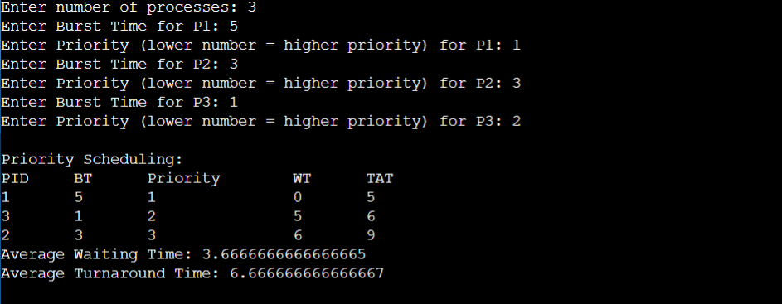

Task 2: Sequential File Allocation
Code: -
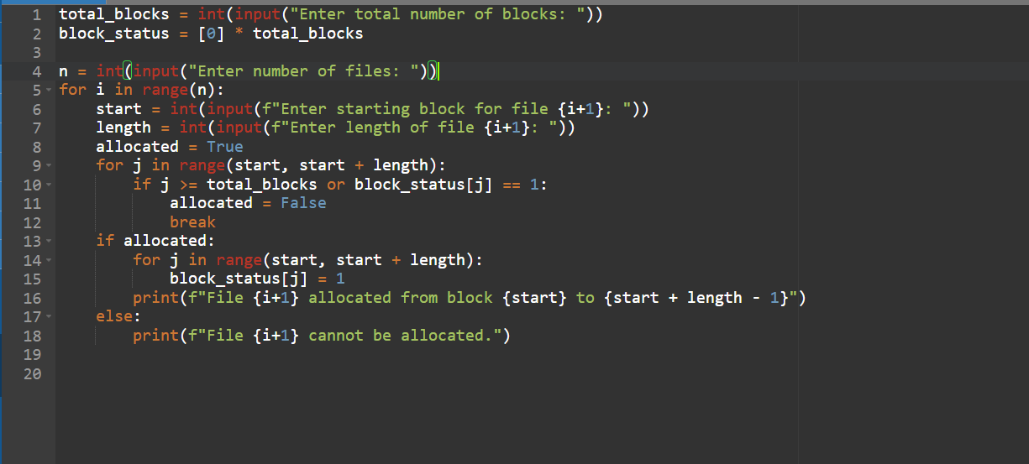
Output: -
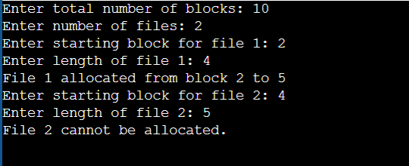

Task 3: Indexed File Allocation
Code: -
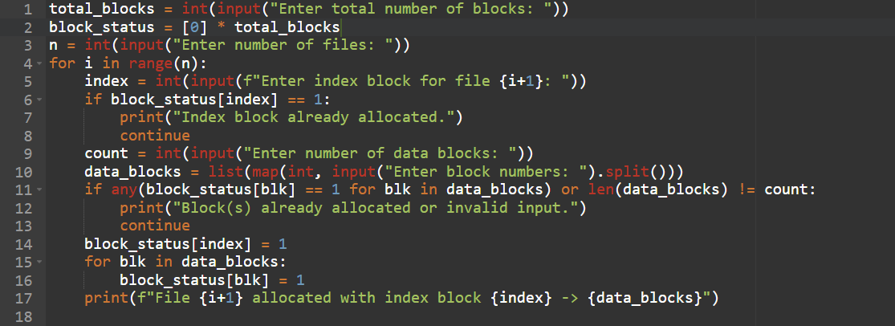
Output: -
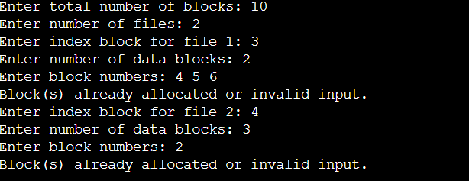

Task 4: Contiguous Memory Allocation
Code: -
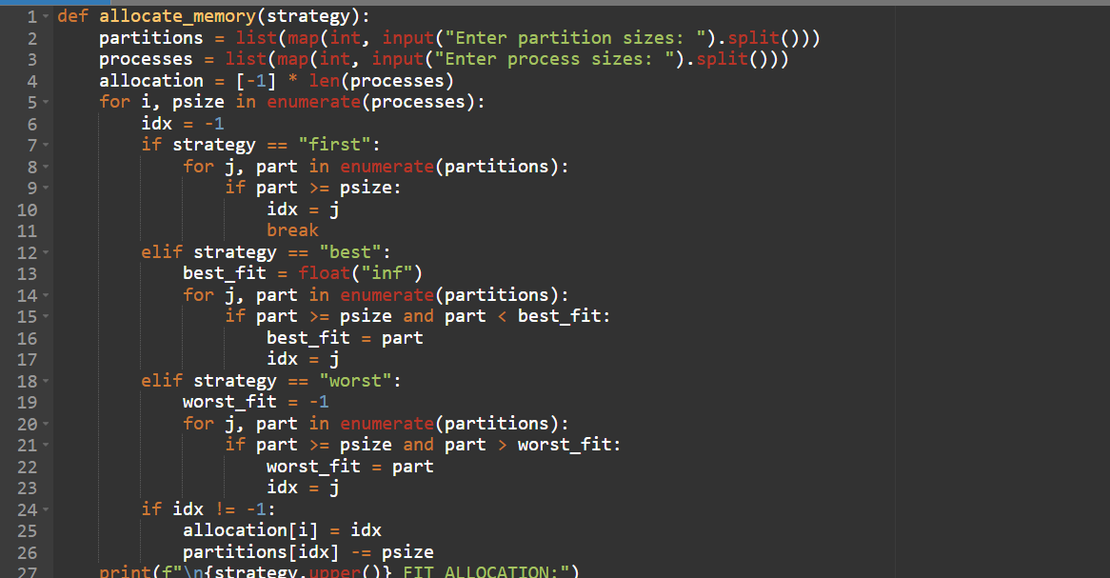
Output: -
Firstfit: -
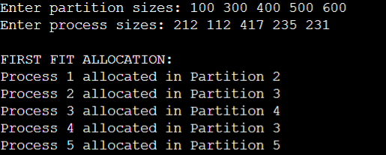

Best fit: -
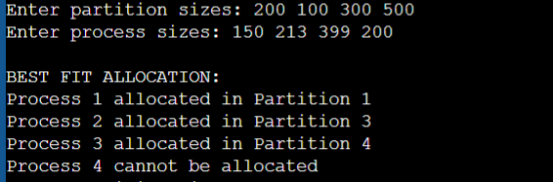

Worst fit: -
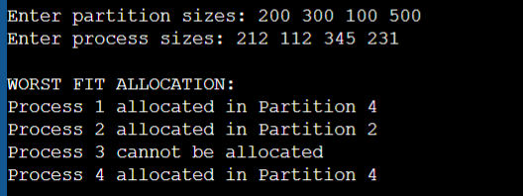
Task 5: MFT & MVT Memory Management
Code: -
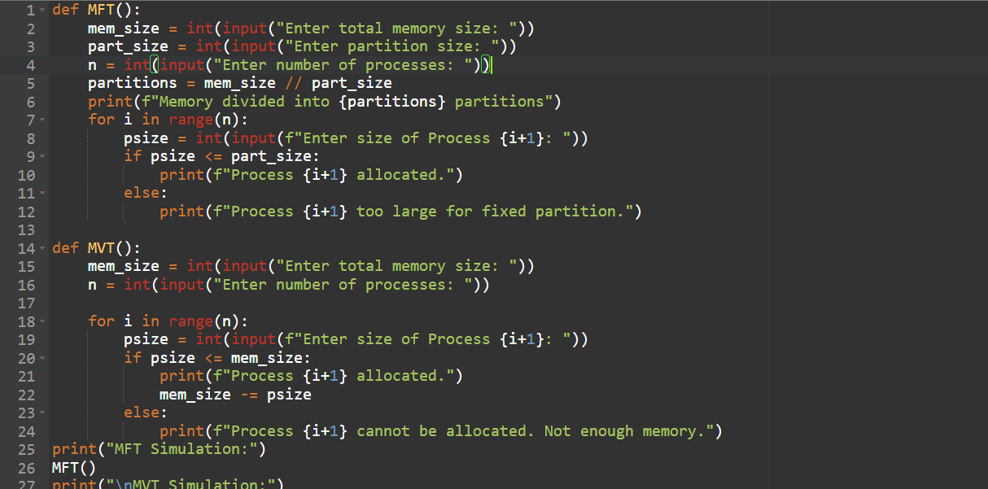
Output: -
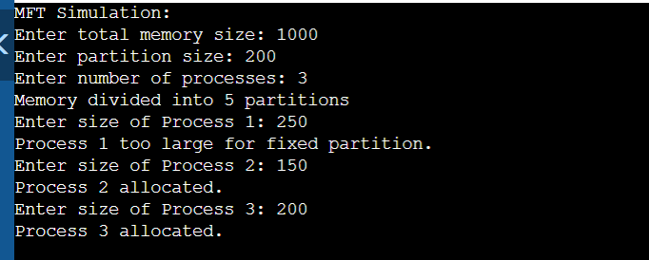

ASSIGNMENT – 4
System Calls, VM Detection, and File System Operations using Python
Sub Tasks
Task 1: Batch Processing Simulation (Python)

